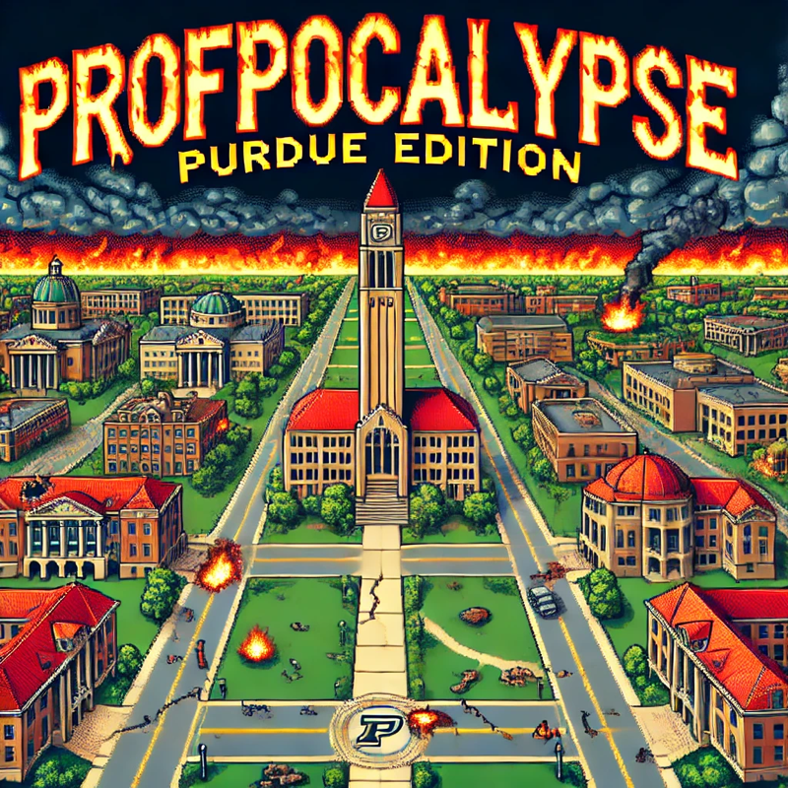**Team 1 - Product Backlog**

*Trey Rosenfeldt, Jonah Irons, Helen Fivecoate, Austin Rogers, Jennifer Sheng, Mohana Barve*

**Problem Statement:**

Our goal is to create a unique gaming experience where users will be able to explore parts of the Purdue University campus and learn about different Professors from all colleges in a fun and immersive experience. Additionally, students and new teachers will be able to learn fun trivia from the classes those professors teach to prepare them for the tougher and more experienced teachers. In our 2D turn-based battle game, it is the year 3025 at Purdue University… In an attempt to keep tuition frozen, the professors from 1000 years prior have been brought back to life, but with a twist - they’re now evil cyborgs (most of them). A few ways this game will differ from other games (such as Pokemon) are: a unique character selection with differing abilities/storylines, quest and achievement implementation, and mini-map functionality. Other additions to differentiate our game from the others will be implemented as we assess our timeline.

**Background Info:**

**Audience**

In our current age of technology, there are many different ways of learning. We would like to give students, or prospective students, the chance to learn about Purdue and what it has to offer through a unique medium - a video game. We want to offer this learning tool so students can create a memorable experience tailored to their classes and majors. This will be a fresh perspective on college exploration and class research, which will make the scope of many classes clearer to the students. Thus, our game is targeted towards anyone wanting to learn more about Purdue’s campus and class structure, specifically aimed towards high school students who want to discover if Purdue is the school for them. With this, our domain is games, or more specifically video games.

**Similar Platforms**

There are many games and websites that are similar to different pieces of our game. Games like Pokemon have similar turn-based battle formats and many other students have used the Purdue campus as an inspiration for their games. In addition, we aim to make our game informative, so our game draws in pieces of Purdue information that could be similar to what is found on the Purdue website and Brightspace, but in a more engaging format.

**Limitations**

Learning about Purdue and the classes you might take in a fun and informative environment is a niche problem but is something that I have not seen done before. The limitations of similar platforms include a long boring but almost complete understanding of what your classes may teach you and a fun but non-informative game. Being able to learn about your classes and solving actual problems in those classes may be more beneficial for early students than just reading what the class is about on the Purdue webpage. Allowing students to interact with the campus and with the teachers is another limitation of the Purdue website.

With this project, we are aiming to have an interactive solution to have students not just see what classes they may take in the future but understand certain questions they may have to answer in those classes while also being able to see teachers who teach those classes.

**Functional Requirements:**

**Game Setup and Core Functionality**

1. As a Player, I would like a login and account creation so I can see the leaderboards and (if time allows) go into multiplayer areas.
2. As a player, I would like to save my game and be able to log into the same location, and point of the story I was at when I exited.
3. As a player, I would like to delete my save from the game.
4. As a player, I would like to interact with a pause screen to adjust the volume of sound effects and music.
5. As a player, I would like to interact with a pause screen to adjust the brightness of the screen and contrast.
6. As a player, I would like to be able to set custom key bindings for controls in the game.

**Exploration and World Interaction**

1. As a player, I would like to be able to move through the map using keyboard controls (up, down, left, right).
2. As a player, I would like to be able to view a mini-map of Purdue University for easier navigation during exploration and quests.
3. As a player and Purdue student, I would like to explore where buildings are on the main campus and their names.
4. As a player and Purdue, I would like to go into classrooms and into other buildings.
5. As a player and Purdue student, I would like to be able to learn about Purdue trivia by interacting with the environment and NPCs.
6. As a player, I would like to see teachers in their office hours and the ability to see classes full during their class time.
7. As a player, I would like to go onto a computer UI to see what classrooms are full during what time of day.
8. As a player, I would like to be able to experience different biomes/regions within the Purdue campus.
9. As a player, I would like to experience different music /audio depending on where I am on the map.
10. As a player, I would like to experience different music/audio depending on who I am battling / whether I am in combat or not.
11. (If time allows) As a Player, I would like to be able to explore/unlock fast-travel locations.
12. (If time allows) As a Player, I would like to have buses around Purdue that I can fast-travel with.
13. (If time allows) As a Player, I would like to see major events on campus like the grand pre and industrial round table, as well as things like clubs and Greek life.
14. (If time allows) As a Player, I would like to have daytime and night time and time when I can go to my classes.
15. (If time allows) As a Player, I would like to have seasons along with events happening at the correct time of year.
16. (If time allows) As a Player, I would like a calendar to see the events and what day it is.
17. (If time allows) As a Player, I would like to have to go to sleep to skip the night and if I don't sleep I get fatigued.

**Character and Customization Features**

1. As a player, I would like to be able to choose between different characters to fight with.
2. As a player, I would like to be able to customize the head (this includes hairstyles, facial hair, mouth structure, and eyes) and body (this includes clothes, ties, bowties, and colors of clothes) of my character.
3. As a player, I would like to be able to play different characters from a database of different pre-made characters that I meet throughout the game.
4. As a player, I would like to have a class system for my characters (e.g. general fighter, hard hitter, healer, etc.) during battle.

**Combat and Items**

1. As a player, I would like to battle random enemies as I travel through the map
2. As a player, I would like to be able to use different attacks in battle.
3. As a player, I would like to be able to switch between character items during battle.
4. As a player, I would like to be able to use items that enhance my battling power and provide healing.
5. As a player, I would like to be able to view my character abilities and item inventory outside of battle.
6. As a player, I’d like to be able to collect items I encounter while roaming around the game.
7. As a player, I would like to see all of the items I am able to collect and which ones I have collected.
8. As a player, I would like to be able to battle boss professor cyborgs that grant greater rewards than NPCs do.
9. As a player, I would like to be able to develop different battle strategies based on which college my enemy is from.
10. As a Player, I would like to have a HUD with things like being able to see how many attacks I have left and being able to see how much more experience I need to level up and a health bar.
11. As a player, I would like to be able to have items that can refresh the amount I can use an item or have an item that can increase the damage of an item.
12. As a player, I would like to level up and be able to use that to make my items stronger.
13. As a player, I would like to have level-ups of my items (similar to evolutions in Pokemon)

**Quest and Achievement Progression**

1. As a player, I would like to be able to unlock and complete quests from NPCs to unlock new content.
2. As a player, I would like to be able to see cutscenes for key moments during the main quest.
3. As a player, I would like to be able to see cutscenes for the introduction as well as a final graduation scene where you can traverse walking on the stage.
4. As a player, I would like to be able to unlock achievements as I progress through and make choices throughout the game.
5. As a player, I would like to have a quest menu so I can see what I need to complete, as well as potential rewards for completing these quests.
6. As a player, I would like to change majors (this means having the teachers and buildings for full majors).
7. As a player, I would like to add minors (this means having the teachers and buildings for full majors)
8. As a player, I would like to go onto a computer UI to see my graduation status and when I need to do my classes.
9. As a player, I would like to talk to my academic advisor when I need new classes.

**Tutorial and Learning Features**

1. As a player, I would like to be able to have a tutorial experience to ease me into the controls of the game.
2. As a player and Purdue student, I would like to see what classes are required for me to graduate/finish the game.
3. As a player and Purdue student, I would like to see the classes I will take each semester and which classes I need for prerequisites.
4. As a player and Purdue student, I would like to learn which classes in specific majors are more complex and in what order Purdue requires you to take them
5. As a player and Purdue student, I would like to learn where the classes are whether that is large lecture halls or small classes.
6. As a player and Purdue student, I would like to learn which teachers in specific majors are more complex, what classes they teach, and where their office is.

**Multiplayer and Social Features**

1. (If time allows) As a Player, I would like to have a multiplayer area.
2. (If time allows) As a Player, I would like to communicate with online players.
3. (If time allows) As a Player, I would like to have a leaderboard about who had the quickest completion time.
4. (If time allows) As a Player, I would like to have a leaderboard about who had the highest percentage of questions answered correctly.
5. (If time allows) As a Player, I would like to see a stats page about how I did and things like how long I walked or how many items I collected, etc.

**Non-Functional Requirements:**

**Architecture and Performance**

We plan to develop the game entirely through Godot, which is an open-source game engine for creating 2D and 3D games. Godot handles all aspects of game development and design, such as character modeling, scene creation and manipulation, physics, movement, and audio, and contains support for multiplayer games, if necessary. Godot’s custom language “GDScript” will be utilized for development, and it will all be done within a Godot environment.

Godot offers a lightweight development experience, allowing us to have small download sizes and efficient performance for our game - this is crucial, as reducing input delay and latency is vital to a smooth and effective experience. We aim to limit this latency to under 50ms, but striving to keep it as close to a 15-30 ms range. Godot ties seamlessly with Github, which will allow us to control the flow of our development process and monitor new changes and implementations as we work through the different aspects of the development process.

If we deploy the game on the web and/or mobile, we will utilize the built-in Godot services that are in place for a smooth deployment, which will allow for consistency across all game versions, and offer great portability for the product. Save files will be stored locally, on the user's system, as there is no need for a database to store individual player information as the game is single-player. Should we choose to implement Multiplayer, the necessary information and the game itself will be hosted through a remote server such as AWS or DigitalOcean.

**Security**

Security will be a strong point in our project when we are working on the login sequence and page. We will have to make sure that the user names and passwords get saved, hashed, and salted to secure valuable user information while requiring passwords to be at least 8 characters. The game will also securely save the points they were in the game. Saving the point they were in the game includes achievements, location, and bosses defeated. Along with making sure the data is safe we also have to make sure if a flood of requests comes in or if someone is trying to do specific attacks our program is prepared and can handle/timeout the user account where 5 failed attempts will trigger a temporary lock.

**Usability**

The interaction with the game’s UI/UX is very important, as a smooth and comfortable experience is necessary for immersion to be preserved, as well as to ensure the learning experience is not interrupted. The response time of each button should be minimal, aiming to be under 40ms, and reducing lag and stuttering is a priority to ensure a proper gaming experience. Similarly, ensuring that load times stay within 10 seconds (on the high end) will maintain proper immersion. The log-in system will be necessary for saving progress so that a user does not have to restart their learning experience if they run out of time in that session. Implementing this feature and maintaining a smooth experience is vital to the performance of the product, and will be a priority during production.

**Hosting/Deployment**

The game will be contained in a complete game package, which will be downloadable by interested players. The game will be set up so that it can be deployed to the web and/or to mobile, by utilizing Godot’s built-in services. Similarly, if the project develops further, we will utilize Godot’s provided MultiplayerAPI to support multiplayer play, and will host the website through a DigitalOcean or AWS server.